Explore Solar Cells
Measure the efficiency of solar cells

Recommended Grade Level: [ 9th to 12th grades ]

NGSS Science & Engineering Practices: [High School ]
- Asking Questions & Defining Problems. Define a design problem that can be solved through the development of an object, tool, process or system and includes multiple criteria and constraints, including scientific knowledge that may limit possible solutions.
- Planning and Carrying Out Investigations. Collect data about the performance of a proposed object, tool, process or system under a range of conditions.
- Using Mathematics and Computational Thinking. Use digital tools, mathematical concepts, and arguments to test and compare proposed solutions to an engineering design problem.
- Designing Solutions. Optimize performance of a design by prioritizing criteria, making tradeoffs, testing, revising, and re- testing.

Preparation: [ 2 to 4 hours to obtain materials ]

Materials Needed: [ For each group of 3 to 4 students ]

• Two solar cells
• Two Volt/Amp meters to measure volts (1 to 10 volts) and amps (0.01 to 10 amps)
• A metric ruler or meter stick
• 5 clip leads with two alligator clips on each end. Two red, two black, one another color.
• Sunlight (or for in-classroom use on a cloudy day a 100 Watt incandescent bulb in a gooseneck lamp)
• A small DC electric motor that will run on 0.5 volts.
• A small piece of masking tape.

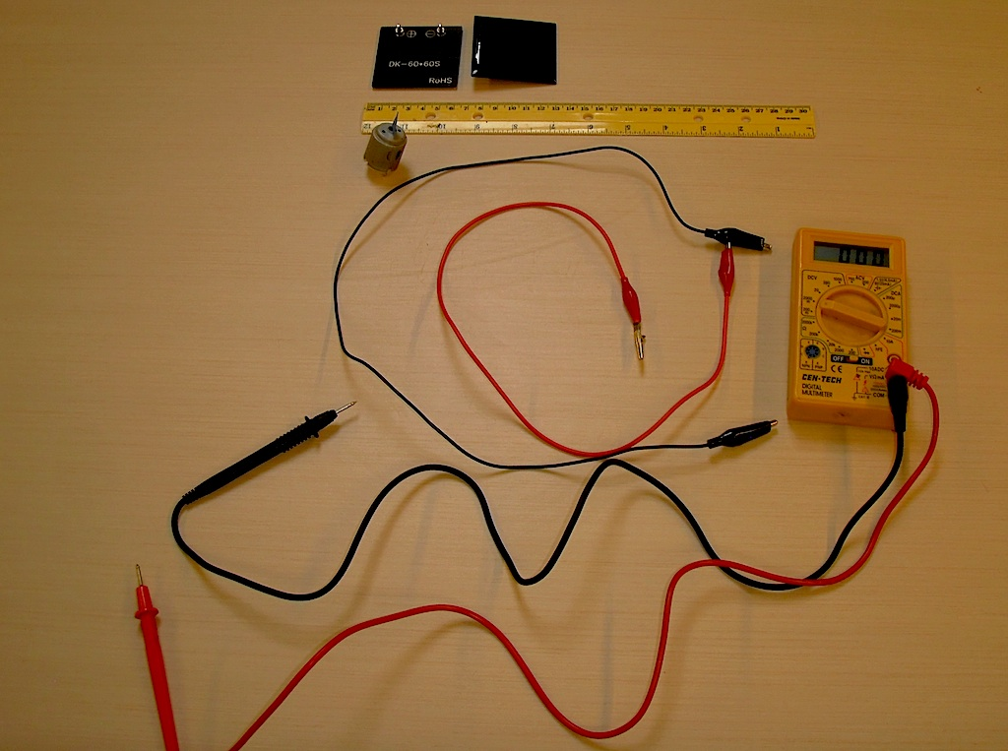

Background Information

Solar cells convert the energy in light into electrical energy. Measure the voltage across the terminals of a solar cell and the current flowing through to solar cell to find the power delivered by the solar cell. Calculate the ratio of electrical power out to solar power in to estimate the efficiency of the solar cell.

What To Do

Measure the open circuit voltage of the solar cell

In a sunny place (or under a floodlight) set the meter to the DC voltage scale so that it can measure a few volts. Connect the positive terminal of the meter via a red clip lead to the positive terminal of the solar cell, and the common or COM terminal of the meter with a black clip lead to the negative terminal of the solar cell. A voltmeter has very high input impedance (resistance) so connecting a voltmeter across a solar cell is similar to an open circuit. Measure the voltage across the solarcell, this is called the open circuit voltage of the solarcell, V_{oc}. Investigate how the V_{oc} changes as you tilt the solar cell in sunlight or lamplight. Ask your students how the measured voltage changes as they tilt the solar cell.

The solar cell measured for this experiment had a V_{oc} = 1.2 volts in full sunlight.

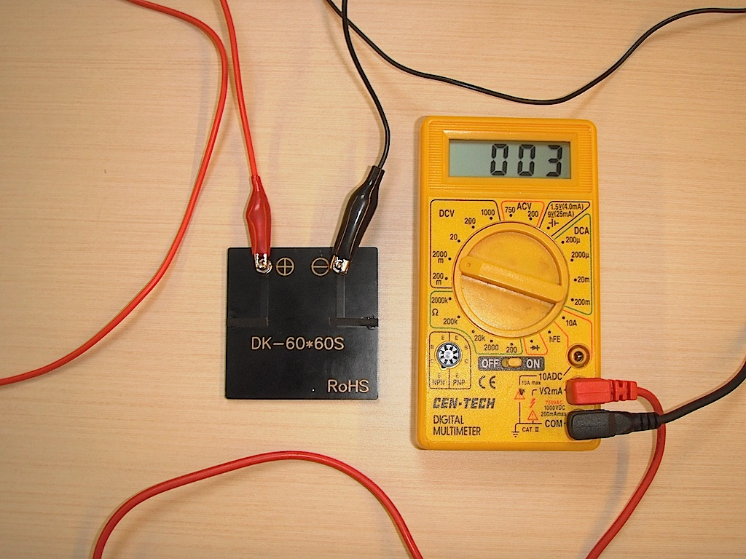
In this image we show the connections on the back of the solar cell.

Measure the short circuit current through the solar cell

Set the meter to DC amperes on a scale that will measure a few amperes of electrical current. Connect the positive terminal of the meter via a red clip lead to the positive terminal of the solar cell. (Note, there may be a separate terminal for measuring amperes.) Then connect the common or COM terminal of the meter with a black clip lead to the negative terminal of the solar cell. An ammeter has very low input impedance (resistance) so connecting an ammeter across a solar cell is similar to a short circuit. Measure the current through the solar cell, this is called the short-circuit current, I_{sc}. Investigate how the I_{sc} changes as you tilt the solar cell. Ask your students to describe how the current changes as they tilt the solar cell.

The solar cell measured for this experiment had I_{sc} = 0.48 amps in full sunlight.
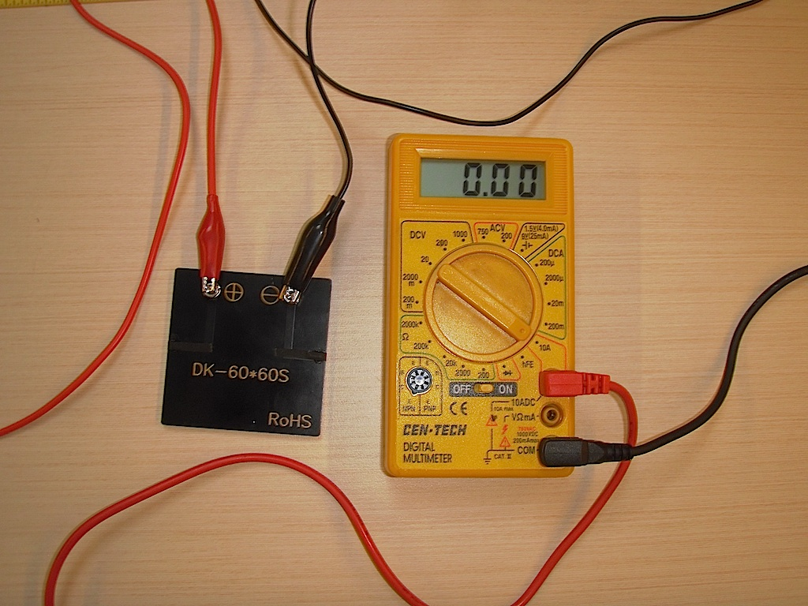
Some meters require moving the input lead to measure amperes.

Investigate a solar powered motor

Put the piece of masking tape on the shaft of the electric motor. Make sure the motor spins freely. Connect the two terminals of the solar cell to the two terminals of the electric motor.
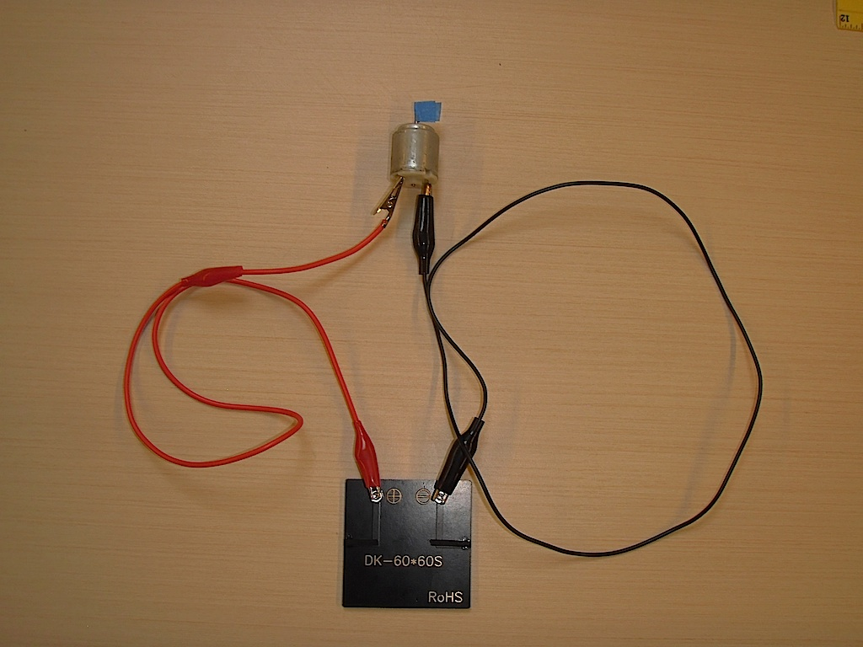
Notice how the motor shaft spins when the solar cell is in the sun. Tilt the solar cell to maximize motor speed. Notice how motor speed changes as you tilt the solar cell away from its maximum orientation. Be careful not to shade the solar cell as you hold it. Power production is greatest when the solar cell is oriented perpendicular to a line radiating out from the sun that passes through the solar cell.

Measure the voltage across the motor as it runs at maximum speed. Measure the current through the motor.

You can use two meters to measure voltage across the motor and current through it at the same time, or use one meter to make two sequential measurements.
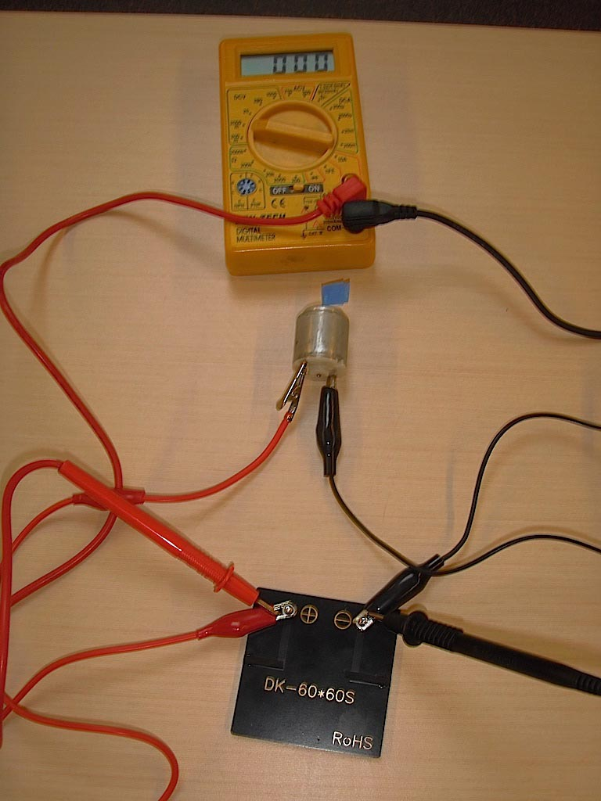
Measuring voltage, solar cell, motor and meter are in parallel.

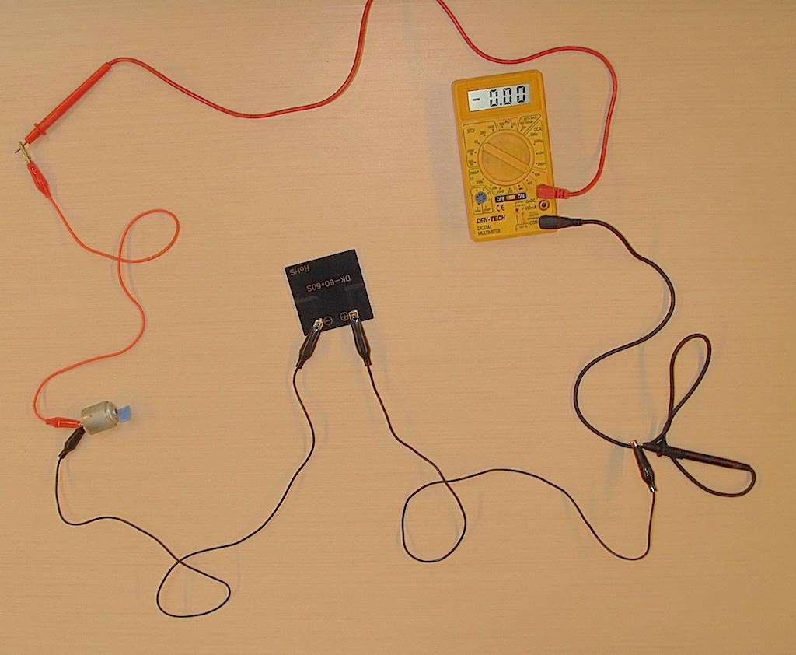
Measuring Current, solar cell, motor and meter are in series.

The solar cell and motor used in this experiment had V = 1.1 V and I = 0.11 A.

The Power produced by the solar cell and its efficiency

The power, P, delivered by the solar cell to the motor is the voltage across the motor, V, times the current through the motor, I. (Lori Lambertson suggests that you can remember the power equation by noting that the symbol for power, P, will remind you to calculate the product.)

P = V I

For the solar cell and motor we used the power delivered was P = V I = 1.1V * 0.11A = 0.12 watts.

The maximum possible power from the solar cell P_{max} will be less than the product of the open circuit voltage times the short circuit current.

P_{max} = V_{oc} * I_{sc} = 1.2 * 0.48 = 0.54 W

To measure the exact value of maximum power produced by a solar cell requires plotting a voltage versus current curve for the solar cell. This will be described in the Going Further section below.

Let’s use this estimate for the maximum power to calculate the maximum efficiency, E, of the solar cell.
The efficiency is the electrical power out divided by the solar power in. We need to calculate the solar power arriving at the solar cell. The solar constant, I_{s}, is the power arriving per meter squared at the surface of the earth from the sun it is I_{s} = 1,000 watt/m². (You can measure the solar constant yourself using this activity: Solar Brightness Measurement.)

To calculate the solar power arriving at the solar cell we need to multiply the solar constant by the area of the cell. The active area of the solar cell in this experiment measured 5 cm x 5 cm = 25 cm² = 0.0025 m² This means that the solar power intercepted by the cell is P_{s} = I_{s} * A = 1,000 * 0.0025 = 2.5 W.

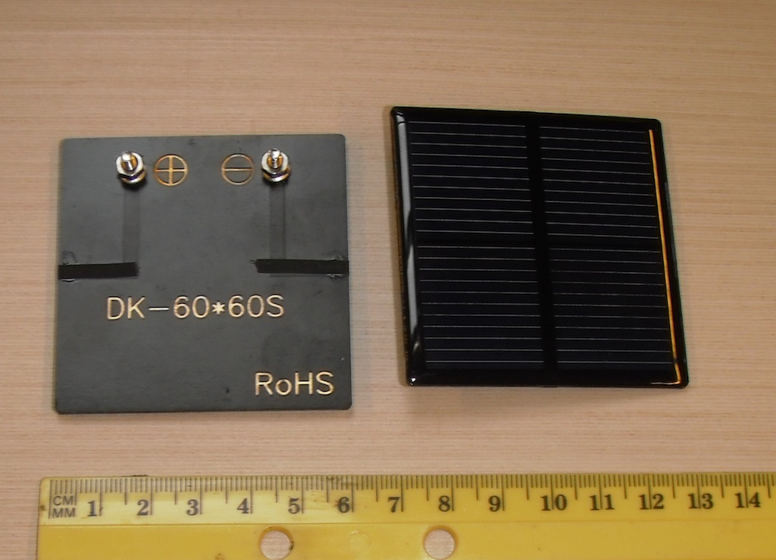
Measure the active area of the solar cell.

Thus the maximum possible efficiency of the solar cell is estimated to be E = P_{max}/P_{s} = 0.58/2.5 = 23%.
The actual value will be less than this.

We can also calculate the efficiency of the solar cell providing power to the motor.
E = P_{m}/P_{s} = 0.12/2.5 = 4.8%

Maximizing power

An important engineering challenge is to try to maximize the power delivered to the motor using solar power. One way to do this is to combine two solar cells in series or in parallel to see if one combination provides more efficient power conversion than the other.

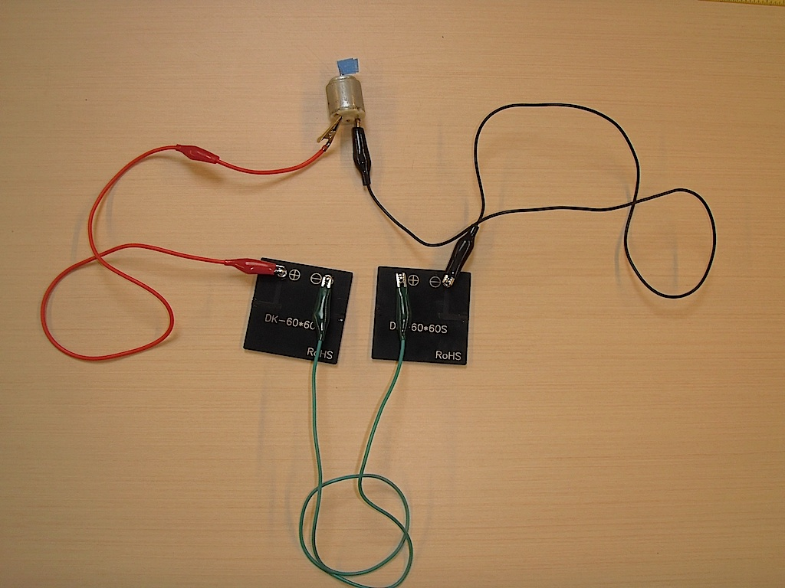

Connecting two solar cells in series, we connect the positive terminal of one to the negative terminal of the other. This will double the voltage across the motor. The motor spins much faster. Measuring the voltage across the motor from two cells in series, V_{s}, and the current through the motor, I_{s} gives us the power.
P = V_{s} * I_{s} = 2.2 V * 0.12 A = 0.27 W

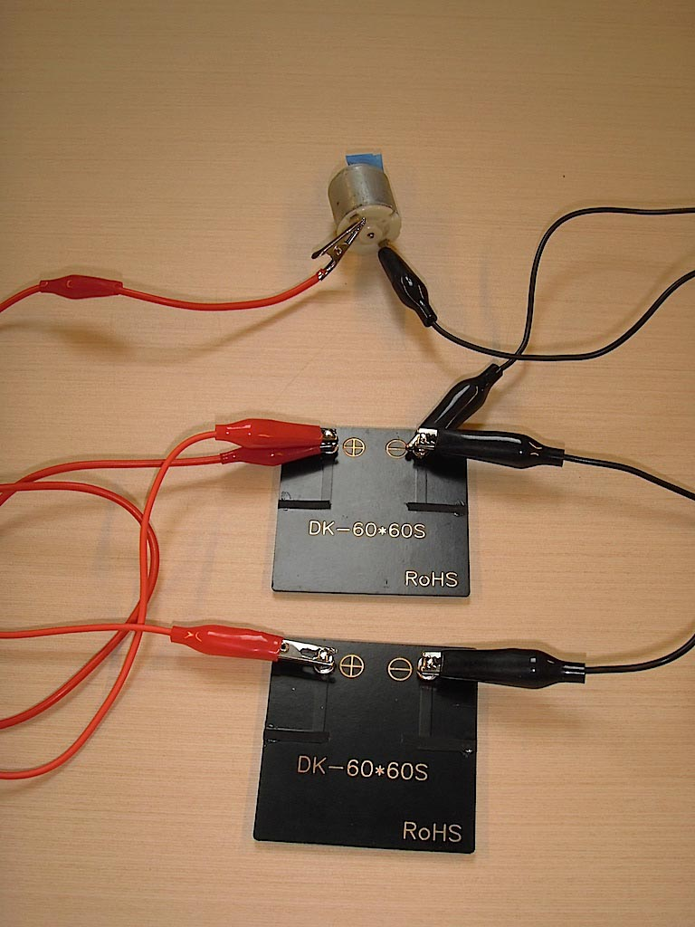

Connecting two solar cells in parallel, we connect the positive terminal of one cell to the positive terminal of the other, and the negative terminal of one to the negative terminal of the other. This produces the same voltage across the motor, but is capable of doubling the current. The motor does not spin faster.
Measuring the voltage across the motor from two cells in parallel, V_{s}, and the current through the motor, Is, gives us the power.
P = V_{s} * I_{s} = 1.1 V * 0.10 A = 0.11 W

More power is delivered by having the solar cells in series. Of course two cells absorb twice the solar power as one cell, so the solar input power is 5 watts.
The efficiency of the series combination is E_{s} = 0.27/5 = 5.5%
The efficiency of the parallel combination is E_{p} = 0.11/5 = 2.2%
The series combination produces more efficient energy transfer from sunlight to the motor.

What’s Going On?

It is important to measure the power delivered by a power source such as a solar cell. Electric power is the product of the voltage across a device and the current through that device. It is also important to measure the efficiency with which a solar cell converts the power from sunlight into electric power. The power provided by the sun per unit area, known as the solar intensity, is expressed as the solar constant, 1,000 Watts per meter squared. This value is reduced by clouds and haze and when the radiation from the sun has to travel a longer path through the atmosphere. It is a good approximation around midday with a clear sky.

The solar cell also has energy losses, some light is reflected from the surface of the solar cell, some of the light is blocked from reaching the solar cell by metal lines on top of the solar cell that conduct electricity through the cell. Each photon of sunlight from the near infrared through the ultraviolet can give energy to one electron in a solar cell. In a silicon solar cell the electron accepts 0.6 electron volts of energy from each photon, any photon energy greater than this is lost as heat. Once the energy of a photon is given to an electron, that electron loses some of the energy as it moves through the resistance inside the solar cell. To make a solar cell more efficient the manufacturers reduce reflected light, and minimize shading of the cell by internal metal conductors.

A solar cell module may contain more than one solar cell. For every 0.6 volts of open circuit voltage there is one solar cell in series. The solar cells in this exploration have an open circuit voltage of 1.2 volts so we know there are two solar cells in series inside the solar cell module. To work efficiently all solar cells in a module that are connected in series must be in sunlight. If one module is in shade it will have a high resistance and block the flow of electric current reducing power and efficiency.

The more photons of sunlight absorbed by the solar cell the greater the electric current. This is why the short circuit current depends so strongly on the orientation of the solar cell. The voltage on the other hand is insensitive it is 0.6 volts per electron. This value is reduced when the cell produces high currents because the solar cell has an internal resistance. Current flowing through this internal resistance decreases the voltage that arrives at the external terminals.

Going Further

To measure the actual efficiency of a solar cell Connect the solar cell to a 10 ohm variable resistor. Then measure the curve of current versus voltage as you change the value of the resistor. At each setting of the resistor measure the current through the solar cell and voltage across the solar. These will be the same voltage across and current through the resistor. Notice that the current produced by the solar cell is constant over a wide range of voltage values. These constant current values occur when the solar cell is attached to low resistance values. Larger resistance values decrease the current and increase the voltage.

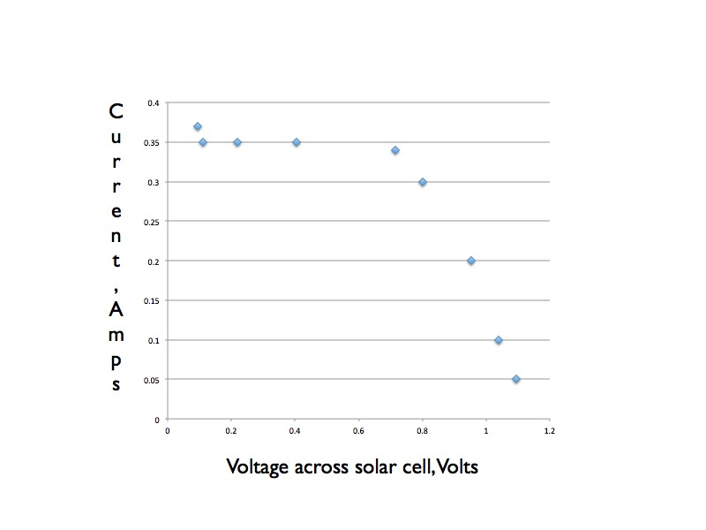
The power at every point can be found by multiplying the current at each point by the voltage at that point.
The resulting curve of power versus voltage has a maximum at 0.72 volts which corresponds to a current of 0.34A The amps and a power of 0.27 W. So the actual maximum efficiency of this solar cell is 11%.

Power from a solar cell versus load resistance.

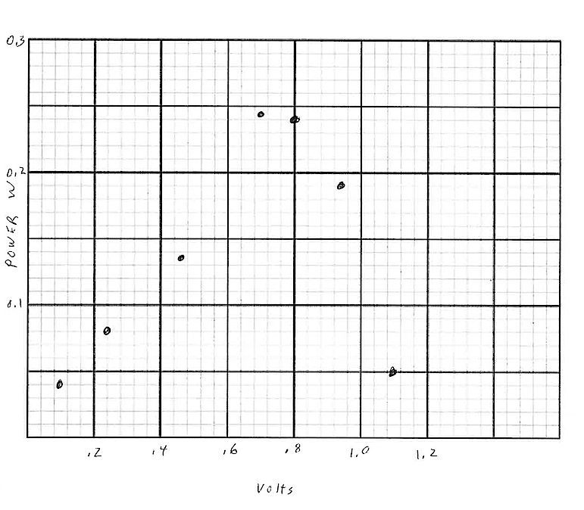

Recommended Web Sites
Solar Schoolhouse book of solar cell activities. 1.7 megabyte pdf

More

Internal Resistance

A power source can often be modeled as a perfect power source in series with an internal resistance. This is a simple model for the inside of a solar cell.
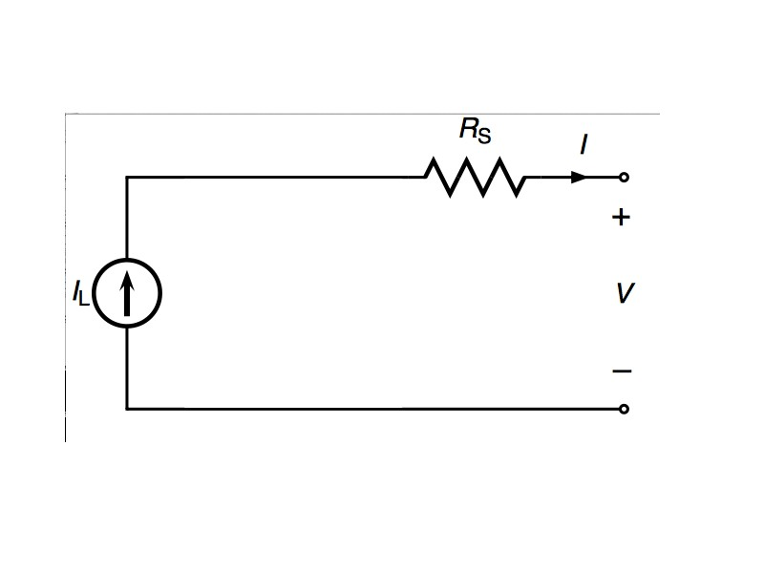
The power delivered to a device by the solar cell is maximum when the resistance of the device, in this experiment a motor, is equal to the internal resistance of the solar cell. Resistance is given by ohms law
R = V/I (Lori Lambertson notes that the resistance begins with R which will remind you it is a ratio.)
The resistance of the motor running with one solar cell was R_{m} = 1.1/0.11 = 10 ohms. The solar cell at maximum efficiency has an internal resistance of R_{s} = 0.72V/0.34A = 2 ohms. Placing two solar cells in series adds the internal resistance so that it is 4 ohms. The 4 ohms is closer to 10 ohms and so increases efficiency of energy transfer. How many solar cells would it take to achieve maximum energy transfer to a motor with a 10 ohm resistance? Placing solar cells in parallel reduces the internal resistance of the combination, two cells in parallel cuts the internal resistance in half making it 1 ohm, this decreases the efficiency of energy transfer.

Error estimation

Scientists and engineers both know that making a measurement can change the thing you are measuring. There is a simple way to estimate the change when measuring voltage and current with meters. It requires two identical meters. Attach one meter and make a voltage measurement, then leave that meter connected and attach a second meter and make the same measurement. Any change in the measurement is an estimate for the error introduced by adding the first meter. You can do the same thing when measuring current. Attach the first meter and make the measurement. You will have to break the circuit to add the second meter in series. The change in the reading is an estimate of the error introduced by making the measurement with one meter. We have found that making measurements of current with the multimeters in this experiment introduces large errors unless the highest amperage scale is used.

